BUILD AN EVENT MANAGEMENT SYSTEM

INIRODUCTION:

OVERVIEW:

An event management system provides campus event planners a flexible fully integrated solution to simplify the event management process and keep your customers happy. while maintaining important reports and data making real estate future planning decisions.

PURPOSE:

* Event Automation
* Access to valuable rate at events
* personalized reports for continuous improvement

PROBLEM DEFINITION AND DESAIGN THINKING:

EMPATHY MAP: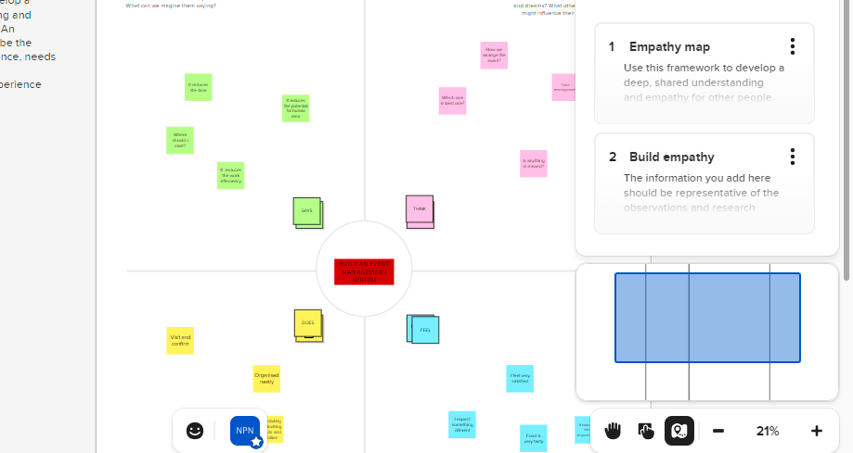

BRAIN STORMING: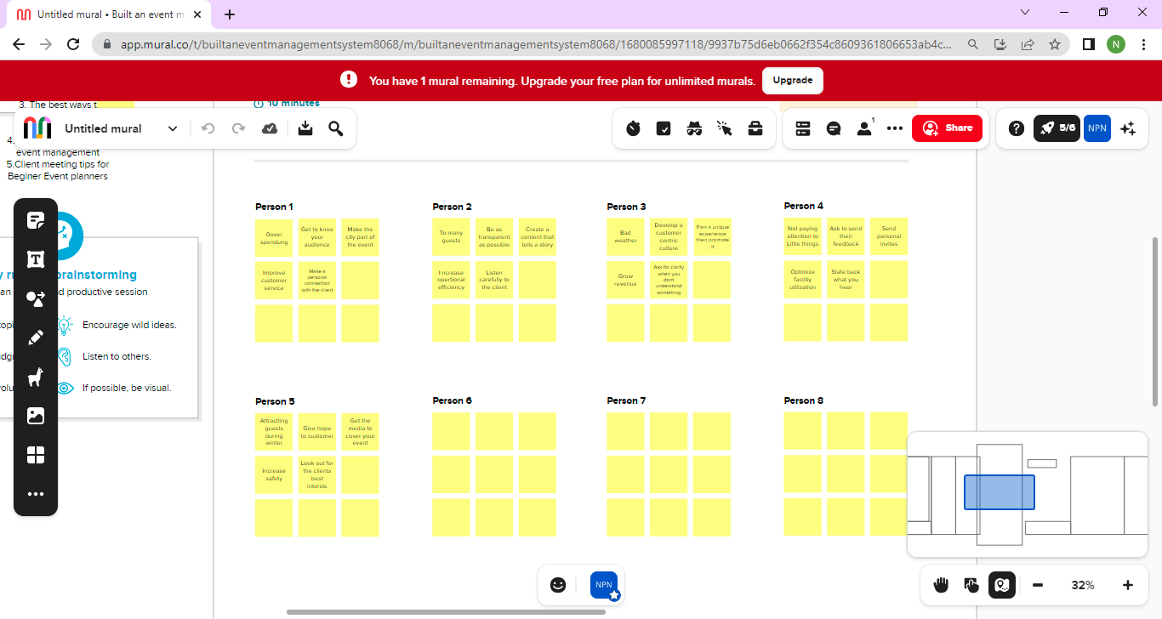

RESULT:

Data model:

Object name Fields in the object

Event Field label Data type

City Text

Start date Date\time

Attendee id Auto number

Phone p hone

Email E mail

Tickets Picklist

Speaker Email E mail

Bio Text area

Event name Lookup

Relationship

Vendor Email E mail

Phone P hone

Event name Lookup

Relationship

Milestone 1:

Create a developer:

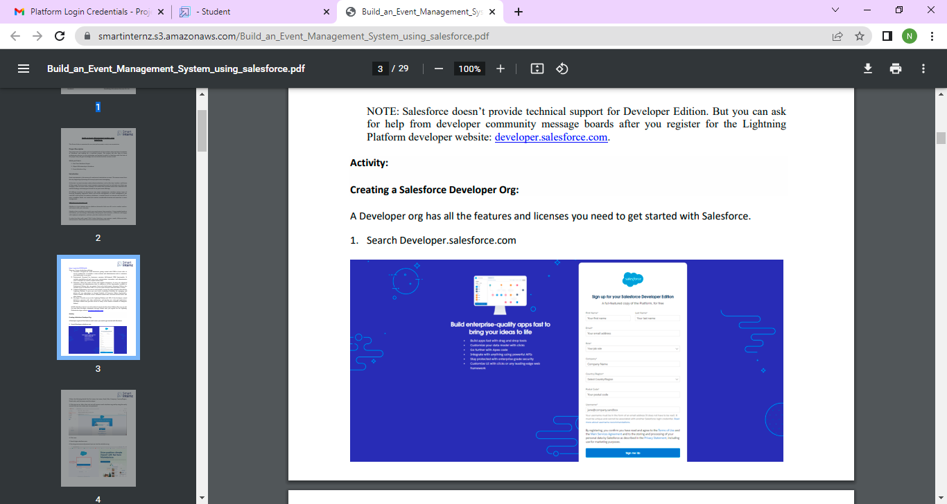

After fill the required fields you will receive the mail to verify the account and login into sales force

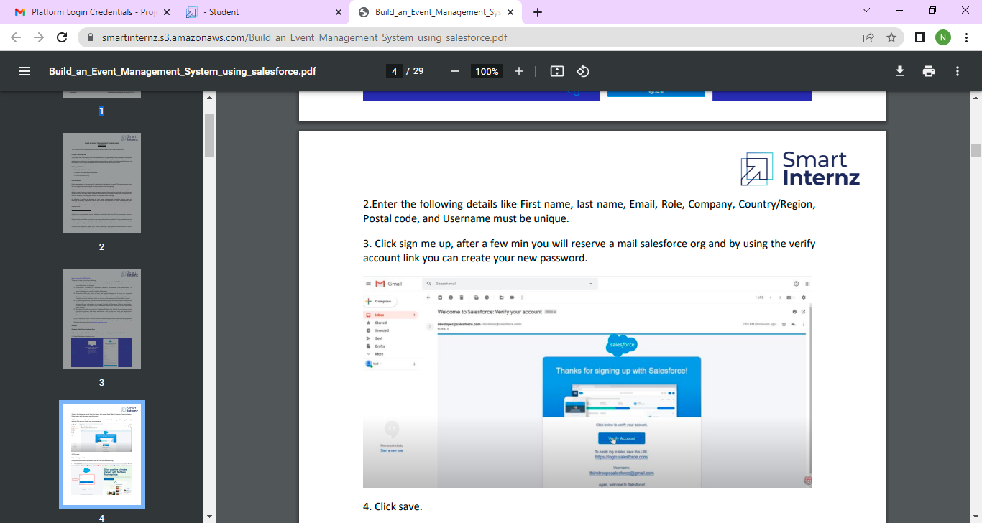

The setup page will appear.

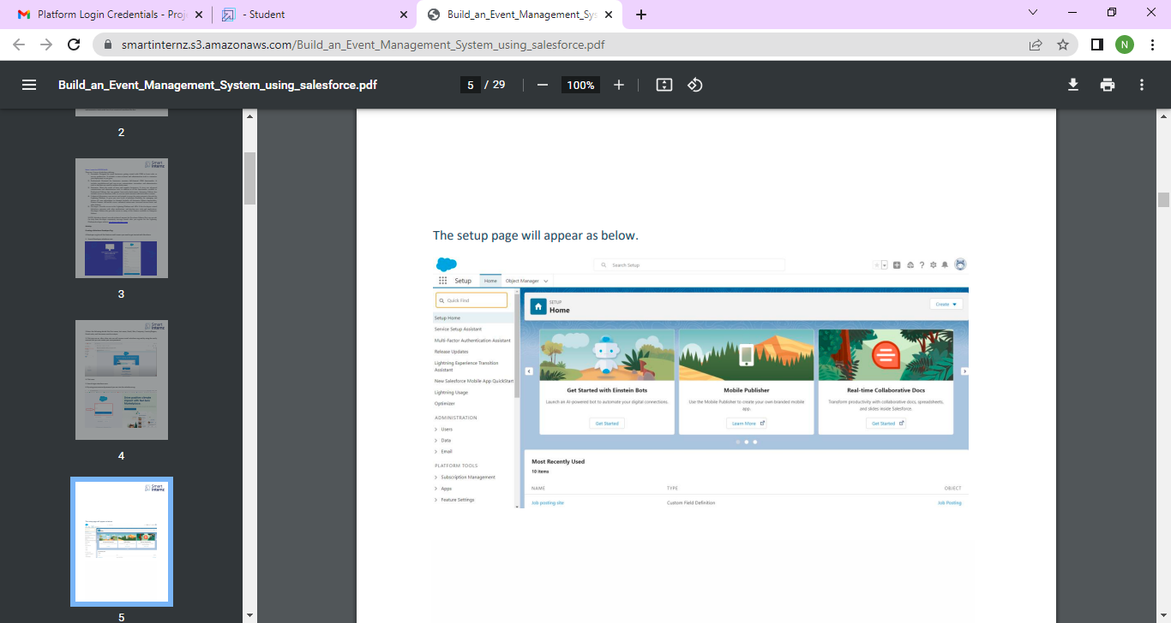

Milestone 2:

Create a object for events , vendors, speakers, attendees.

1. Click the gear icon then select setup
2. Click on the object manager just behind the home tab
3. Extreme right click create then click custom object

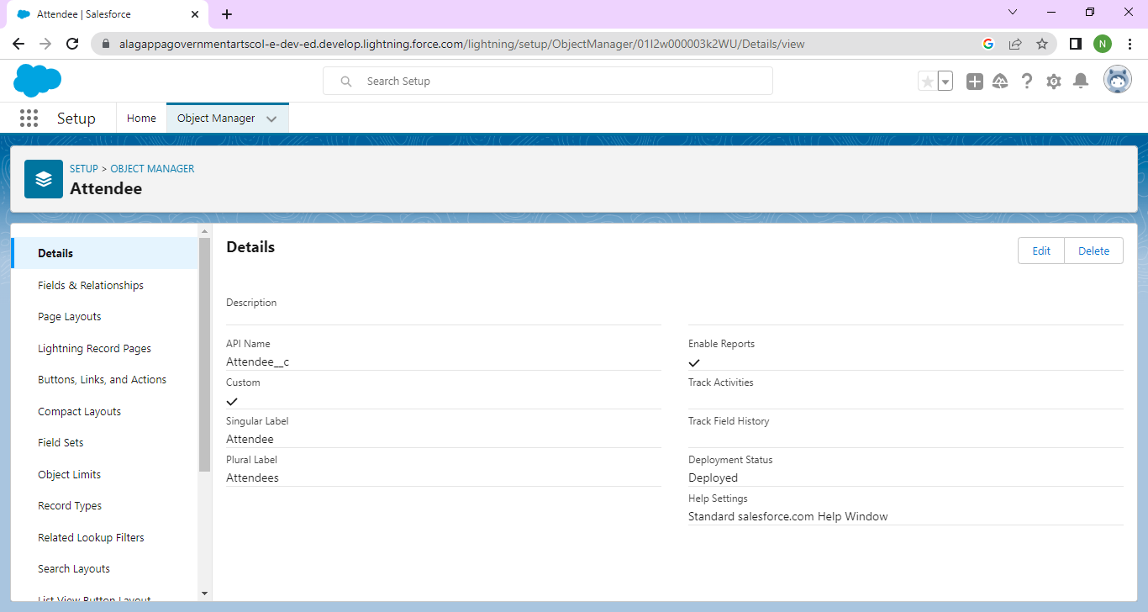

Label :Attendee

Plural label: Attendees

Record name: Attendee name

Check allow the search box

Check allow the reports box

Click save.

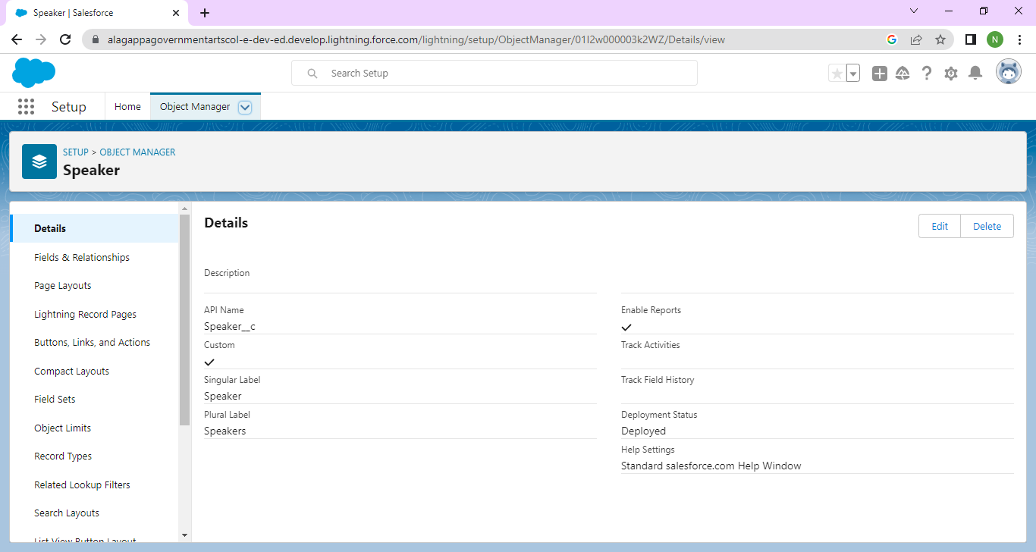

Label: speaker

Plural LABEL: Speakers

Record name: speaker name

Check allow the search box

Check allow the record box

Click save.

Similarly we can create the objects for event and vendor.

Milestone 3:

Creation of tab:

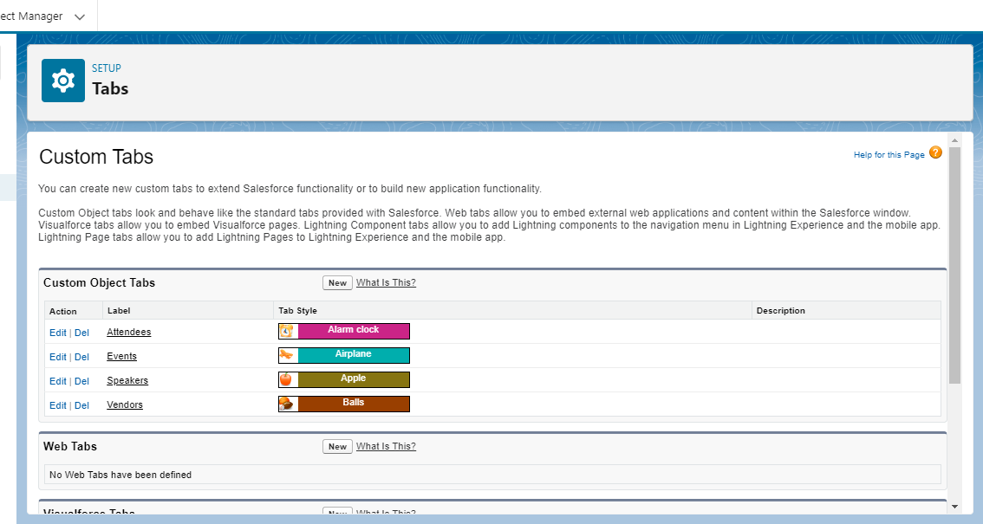 Tab for event:

1. Click on home tab enter tabs in quick find box and select tab
2. Under custom tab click new
3. For object select event
4. For tab style select any icon
5. Click next, next and save

Tab for attendee:

1. Click on home tab enter tab in quick find box select tab
2. Under custom tab click new
3. For object select attendee
4. For tab style select any icon
5. Click save

Similarly we can create the tab for speaker and vendor

CREATE THE EVENT MANAGEMENT CONSTRUCTION APP:

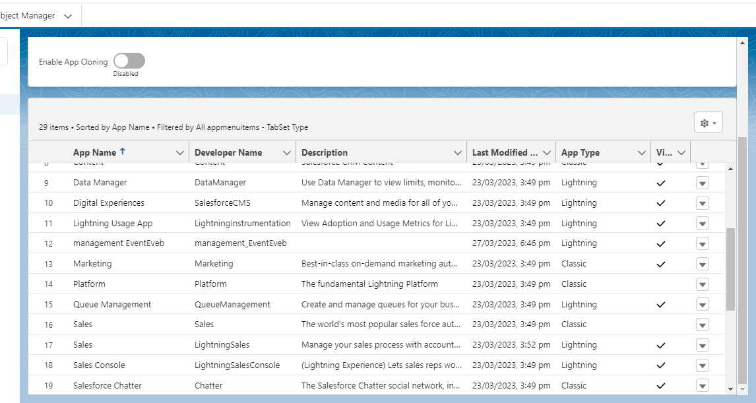

1. From setup enter app manager in quick find and select app manager
2. Click new lightning app. Enter event management as the app name click next
3. Under app options leave as the default
4. Under utility items leave as the default
5. From available items select event, attendee ,vendor, speaker and dashboard
6. From available profiles select system administrator and move it to selected profiles.
7. Click save and finish.

Milestone 4:

CREATION OF FIELDS:

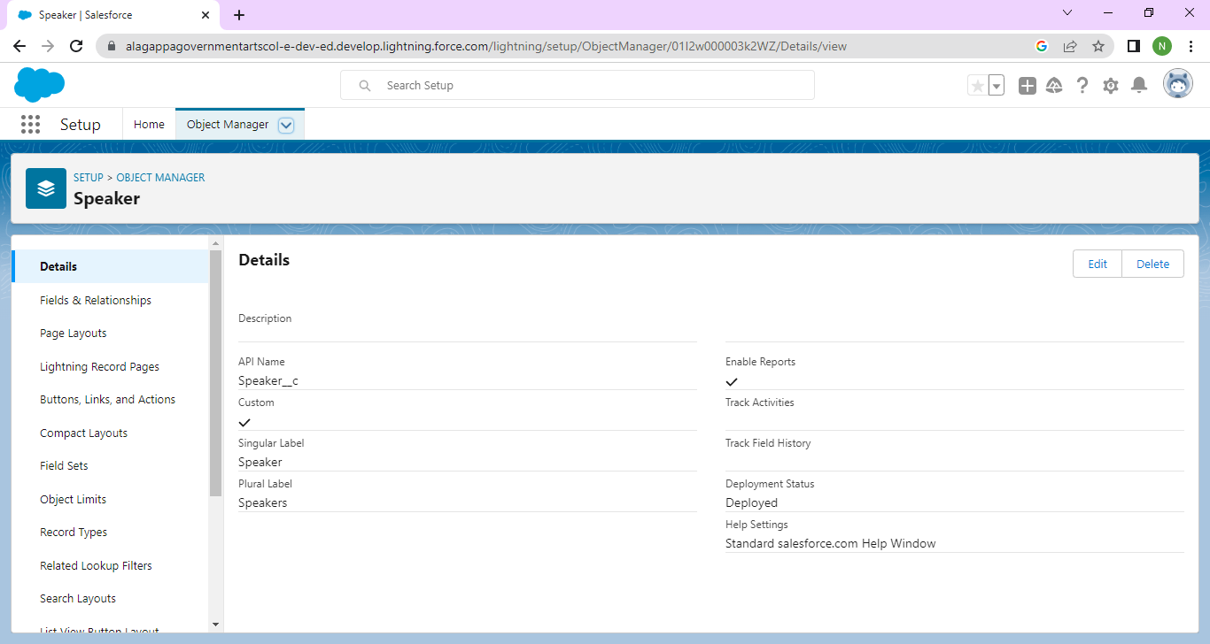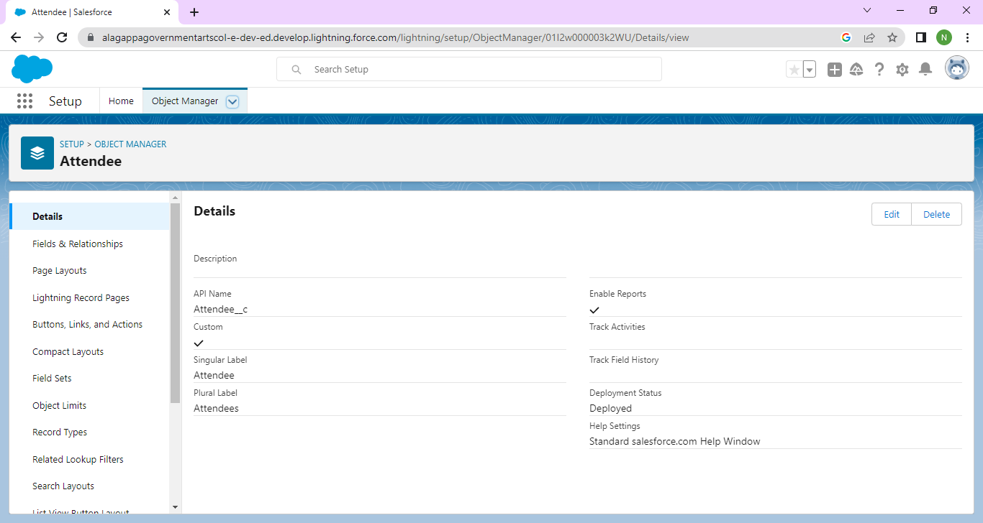

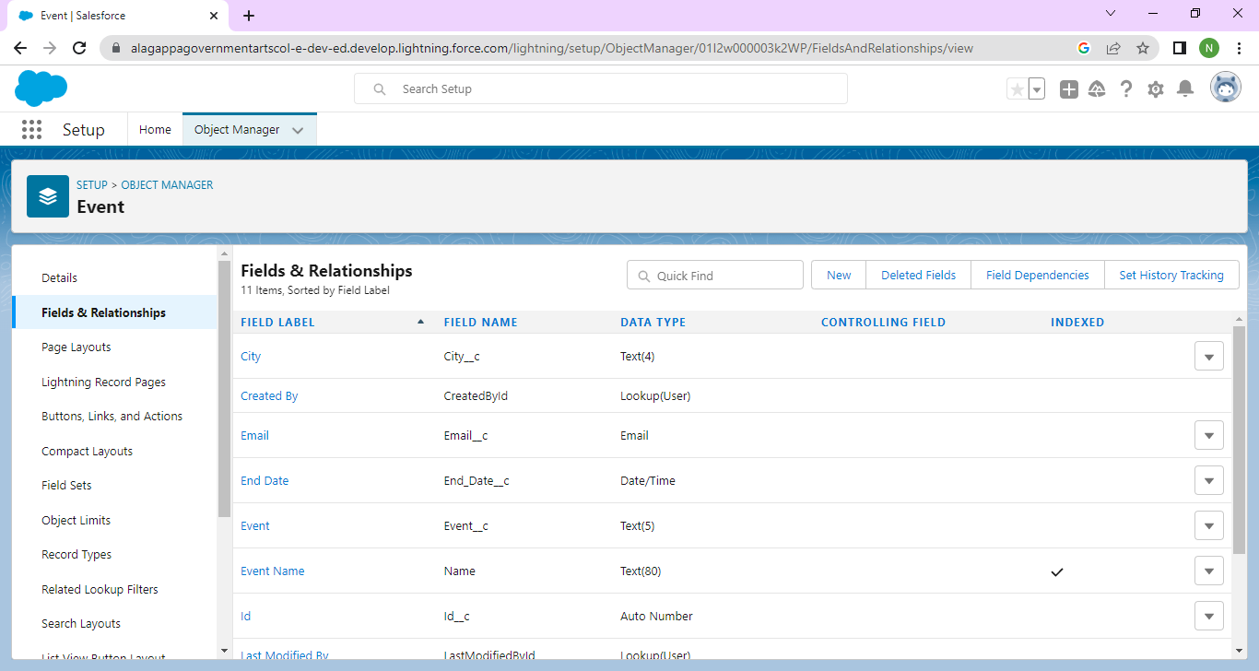

1. Click gear icon and select setup
2. Click the object manager tab next to home
3. Select event
4. Select fields and relationships
5. Select text as the data type then click next
6. For enter label city
7. Click next ,next then click new

CREATION OF FIELDS FOR ATTENDEE OBJECTS:

1. Select Auto number as the data type then click next
2. Enter field label id
3. Click save and new
4. Select phone as the data type then click next
5. Field label enter phone
6. Click next and new
7. Select email as the data type then click next
8. For field label enter email
9. From setup select object manager and select student
10. Click fields and relationships then new
11. Select picklist as the data type and click next
12. For field label enter tickets

Similarly we can create the vendors and speakers.

Milestone 5:

CREATION OF PROFILES:

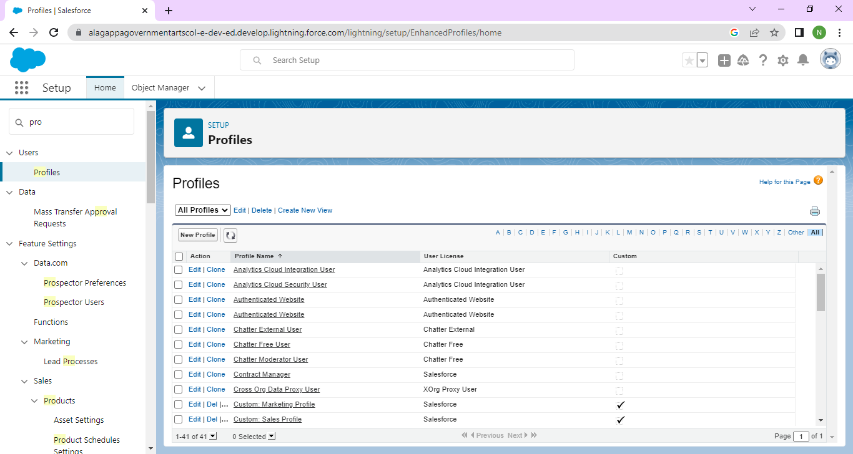

1. From setup enter profiles an quick find box and select profiles.
2. From the list of profiles find standard user.
3. Click clone.
4. For profile name enter Event user profile.
5. Click Save.
6. While still on the Event profile page then click edit
7. Scroll down to custom object permissions and give view all access permissions to the Attendees, vendors and speakers.

CREATE A NAME AS EVENT VENDOR PROFILE:

1. From setup enter profiles and select profiles.
2. From list of profiles find standard user.
3. Click clone.
4. For profile name enter Event vendor profile.
5. Click save.
6. While still on the event profile page then click edit.
7. Scroll down to custom object permissions and give all access permissions to the Attendees, speakers, vendors.

Milestone 6:

CREATION OF USER: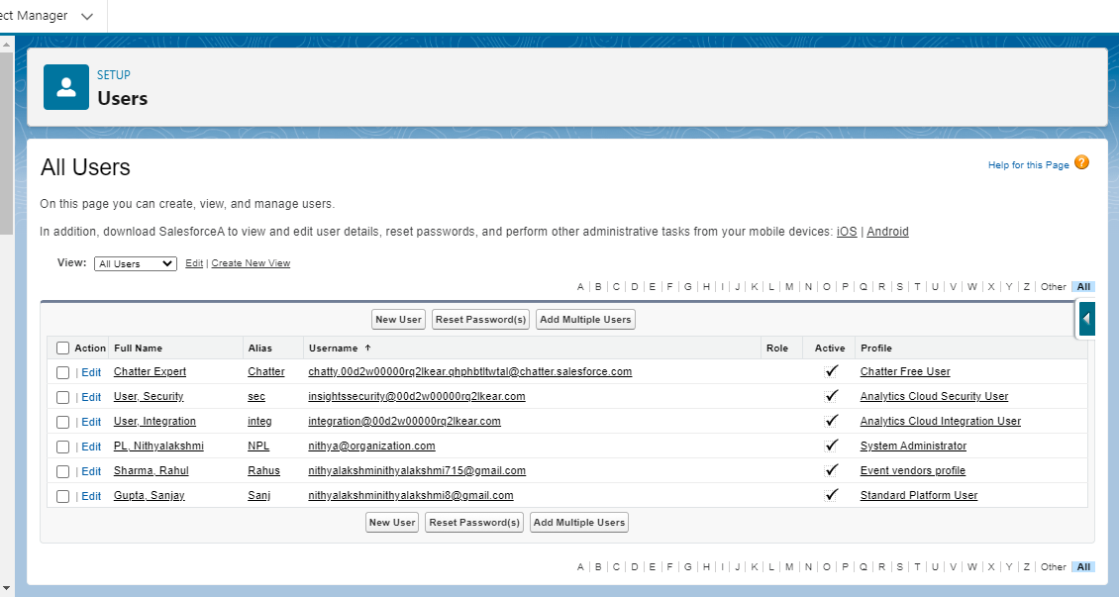

* From the type users and select users
* Click new user
* First name: Sanjay
* Last name: Gupta
* Email: our email
* Nick name: Sanju
* Role: default
* User name : Sales force
* Profile: Event User Profile

Create a user for Rahul Sharma

* From setup type users and select user
* Click new user
* First name : Rahul
* Last name : Sharma
* Alias: Rahus
* User name: [rahussharma@thesmartbridge.com](mailto:rahussharma@thesmartbridge.com)
* Role: Default
* User License: Sales force
* Profile: Event vendor profile

Milestone 7:

PERMISSION SETS:

CREATION OF PERMISSION SETS:

Activity 1:

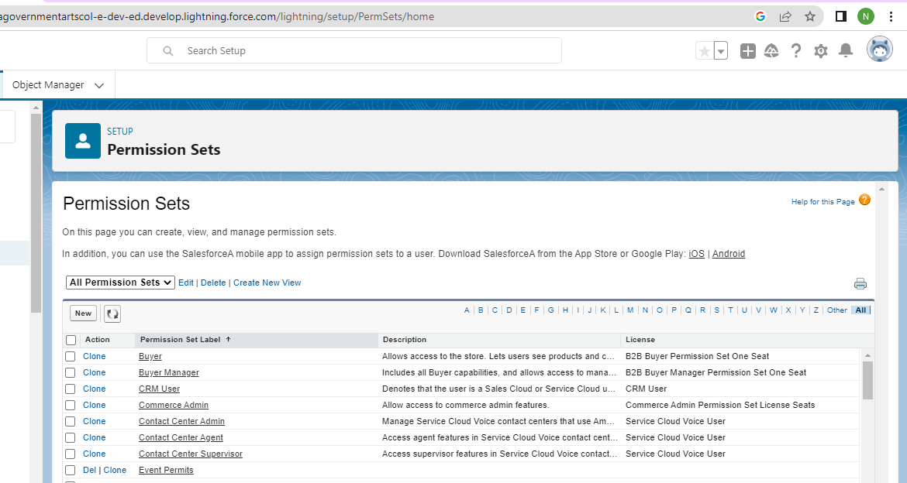

* From setup search permission sets and select permission sets
* Click new
* Enter label as: Event permits and save
* After saving the permission click in the manage assignment
* Now click on add assignment
* Now select the users and click on new

Activity 2:

* From setup search permission sets and select permission sets
* Click new
* Enter label as: Vendor permits
* After saving the permission click on the manage assignment
* Now click on add assignment
* Now select the users and click on new

Milestone 8:

CREATE A REPORT:

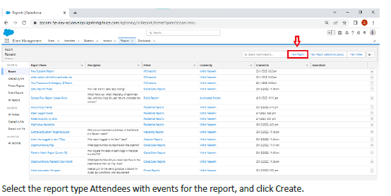

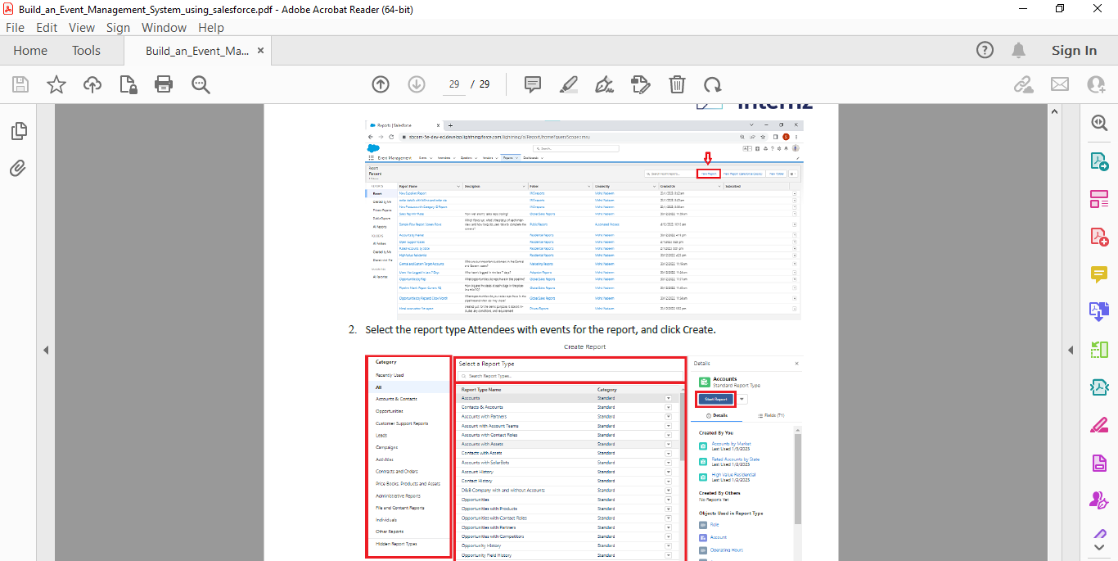

* From the report click new report
* Select the report type Attendees with events for the reports and click create
* Customize your report accordingly and include all fields then save run on it.

TRAILHEAD PROFILE PUBLIC URL:

Team Leader: https://trailblazer.me/id/nitpl1

Team Member 1: https://trailblazer.me/id/muthulakshmi123

Team Member 2: https://trailblazer.me/id/muthuvaishnavi123

Team Member 3: https://trailblazer.me/id/punithasubbiah2515

ADVANTAGES AND DISADVANTAGE OF EVENT MANAGEMENT SYSTEM:

ADVANTAGE:

* They make it less stressful.
* They ensure it runs smoothly.
* They take care of the legalities.
* Event technology helps the event planning, delegate and attendee experience among other things.
* By hosting an event you can spend quality time with your core audience.
* This gives the attendees the opportunity to evaluate the effectiveness of various aspects of your events.

DISADVANTAGE:

* Un conventional work hours.
* Time away from family and friends.
* Job instability.
* Experience requirements.
* High level of responsibility.
* Multiple event at the same time.

APPLICATION OF EVENT MANAGEMENT SYSTEM:

Event management is the application of project management to the creation and development of small and or large scale personal or corporate events such as festivals, conferences, ceremonies, weddings, formal parties, concerts, conventions.

It involves studying the brand identifying its target audience devising the event concept and coordinating the technical aspects before actually launching the event.

FUTURE SCOPE:

* The scope of event management as a career in India is immense.
* This career provides a unique opportunity to rephrase our social beliefs.
* Hosting events can redesign the structure of a city by facilitating economic growth employment opportunities urban development and promoting indigenous culture and heritage.

CONCLUSION:

Event management system is user friendly an cost effective system. It is customized with activities related to event management life cycle .It provides a new edge to management industry. Solution always keep your objectives and goals on top priority while developing any plan of work.